Instructions for Running IB CAS Project

eJournal

Program written by Sang Hoo Lee and David Edwards

Document last updated May 2014

Contents

1. Overview…………………………………………………………………………………..3
2. Running Program...………………………………………………………………………..3
3. Student Journal Entry……………………..……………………………………………….3
4. Admin adds new Student………………………………………………………………….7
5. Admin view Report………………………………………………………………………..8

**Overview**

eJournal is an interactive program that will log journal entries into a database. There are two major parts to the program, Teacher and Student. Teacher may add students, review and print journal entries. Student may only enter journal entries. Each journal entry includes the start and end date for the project, activity name, choose the CAS category, objective, a reflection on the activity and the number of hours in which you participated in the activity.

Program Functions

1. The program adds Journal Report.
2. The program views Journal Report.
3. The program adds new student.
4. The program prints Journal Report

Running Program  
Select the shortcut for eJournal on the desktop. Double-click the shortcut to Start the program.

Student adds Journal Entry

The program requires the student name and ID. Click on the Enter Data button to begin the journal entry. When done hit the Back button and logout.

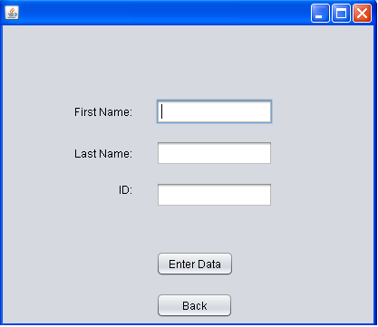

Enter name and ID to log in it is case sensitive.

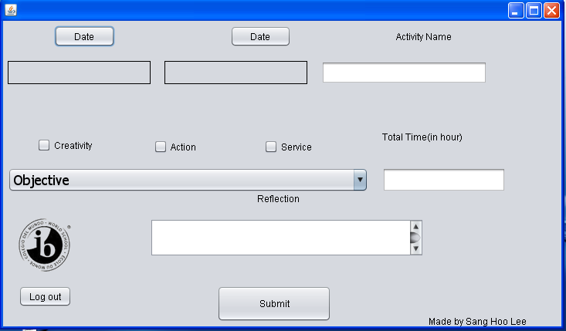

This is entry page that will pop-up after pressing Enter data button.

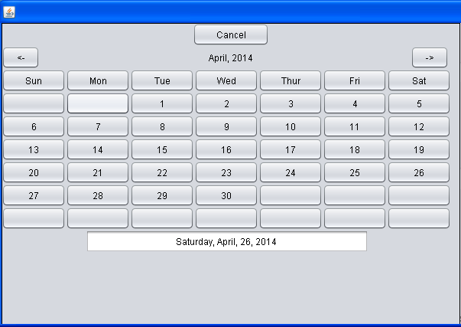

When Start Date or End Date is pressed, the calendar will appear. Press<- or -> to change months, and select the date to set date.

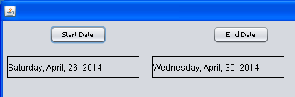

When the dates are selected this is how it should look like.

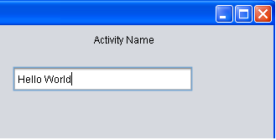

Enter the name of Activity in the given field

E:\New Folder (2)\CAS.bmp

Choose Creativity, Action, and/or Service by check the box for given checkbox

E:\New Folder (2)\Objectivw.bmp

Click the pull-down box to select the objective

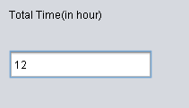

Enter the total hours in this text field. The field only allows numbers

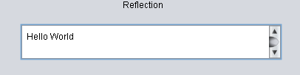

The max character of the Reflection is 1000 characters. Do not exceed it.

E:\New Folder (2)\Submit.bmp

After entering data in all entry, press submit to save data in database

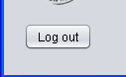

Press log off button to move back to log in page.

Admin adds new student

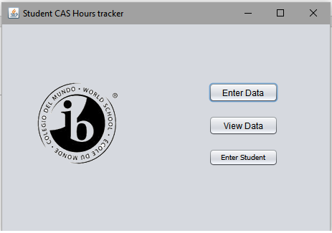Click on the “Enter Student” Button on the screen, and a window like this should appear:

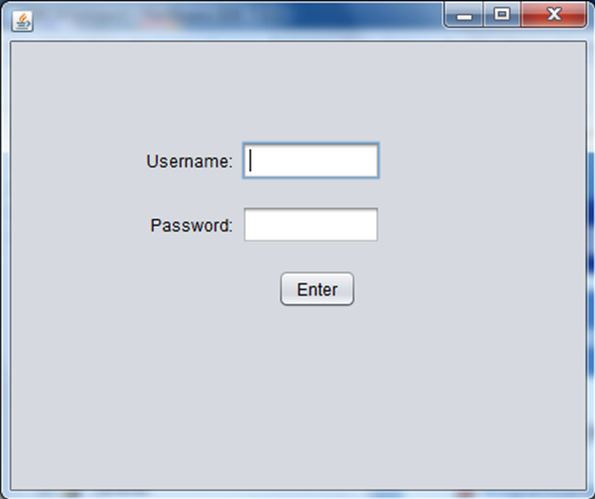

Enter the correct username and password. Click “Enter”

A window should appear like this:

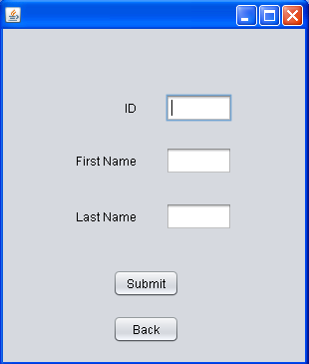

This page is where student data will be entered. Enter IB ID for ID field, First and Last Name in their field and pressing Submit button will store student into the database and Back button will bring back to main page

How to read the info



Click on the “View Data” Button on the screen, and a window like this should appear:



Enter the correct username and password. Click “Enter”

A window should appear like this:

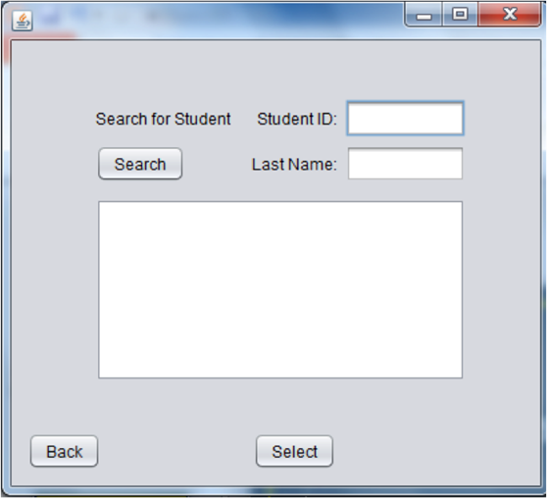

At this window, enter a student’s login ID, his/her last name, and press “Search” to see if they are in the database

If he/she is, the first name, last name, and ID will be displayed in the list below.

Here is an example:

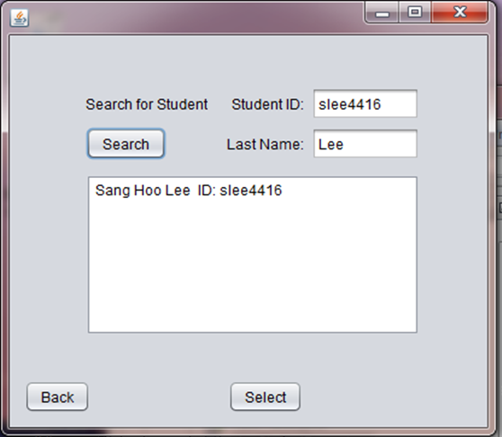

Click on the option in the list and click “Select”

This will take you to a different form. Here is an example:

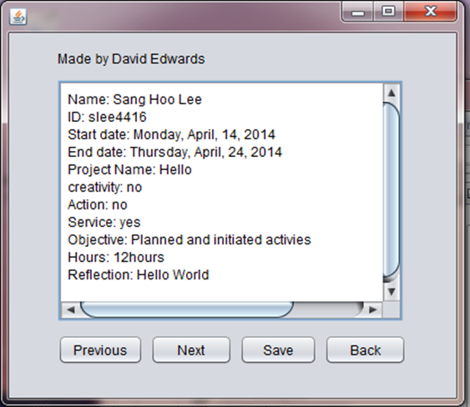

At this form, the student’s first entry for his CAS project will be displayed. You have the option to scroll through their entries by clicking “Next” or “Previous”.

* By clicking “Next”, the form will display the student’s next entry.
* Clicking “Previous” will take you back to the entry you viewed previously.
* Clicking “Save” saves the information on the screen into a text file in the folder “CASreports”, located on the desktop. If the save is successful, a window like this will open on your screen:

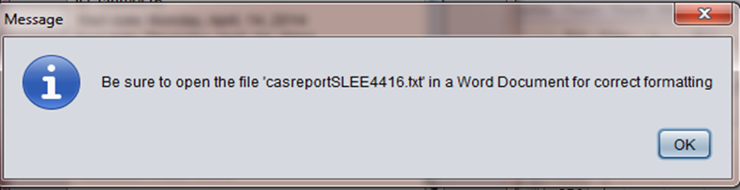

Press “OK”, and be sure to save every entry before exiting the program.

To read the .txt file:

• Open Microsoft Word.

• In the file tab, click open and click on directory of this program

• Choose the folder named “CASreports”.

• Choose the file of your choice (each file is identified by ‘casreport’ followed by the student’s ID).

The ID for the Admin is admin and the password is 1234